The 2022 Awards Program
The North Country Scenic Byway Council (NCSBC) seeks applications for its “2022 Byway Enhancement Awards.” These awards recognize outstanding examples of efforts taken by communities, community organizations, or individuals to enhance their byways:
- By the Byway Award - community efforts that encourage people to pull off the byway to photograph the scenery, take a walk, have a snack, meet friends or otherwise enjoy a few minutes or more at a local rest area, pull-off, or trailhead.
- Read the Marker Award - community efforts that encourage people to pull off the byway to read one of New Hampshire’s historical markers.
Projects completed in 2021 and projects that will be largely completed by September 30, 2022, are eligible for the 2022 awards. Applications for either type of award should be submitted to North Country Council by September 30, 2022. Winners will be announced by the end of October, and non-profit organization(s) associated with each award-winning project will receive (share) a cash award of $1,000.
Goals of the Awards Program
Through this awards program, NCSBC:
- Promotes awareness of the byways via articles in local papers.
- Encourages municipalities, historical societies, conservation groups and others to undertake efforts to improve pull-offs, rest-areas, trailheads, or other locations along the byways.
- Encourages NH DOT, municipalities and others involved in major projects to consider how those projects can improve the North Country’s system of byways.
Our long-term objective is to encourage local efforts that, taken together, will enhance the byway experience for residents and visitors alike, thereby encouraging more people to “Spend a Day on the Byways”.
Spend a Day on the Byways
In the scenic North Country of New Hampshire, almost every numbered state or federal highway has been designated as a scenic & cultural byway. NCSBC is the management entity for this 600-mile network of roads that covers a region that the National Trust for Historic Preservation has called a “National Treasure,” recognizing both its natural beauty and its unspoiled cultural landscapes.
The world-famous White Mountains, located in the center of this region, attract millions of visitors annually. However, the cultural landscapes, historic villages, and recreational opportunities further to the north and west are also well worth visiting for a day, a weekend, or a vacation. These areas are all well-served by the North Country’s scenic and cultural byways, which offer scenic routes if you are headed toward the Connecticut Lakes to go fishing, to Pondicherry for bird watching, to Umbagog National Wildlife Refuge for canoeing, to Dixville Notch for a picnic or toward the Connecticut River to bike along the Ammonoosuc Rail Trail.
Interesting places to stop, such as scenic pull-offs or historical marker sites, create options for spending more time along the byways, whether you are heading off for a day in the wilds, meeting friends for lunch in a nearby town, or simply enjoying an afternoon drive with your family. Providing better places to stop along the byways will encourage visitors and residents to go beyond the White Mountains to explore and enjoy more of this “National Treasure.”

Applying for an Award
Eligible projects include any community efforts that improve a site located along or very close to one of the North Country’s scenic & cultural byways. To qualify for an award, there must be safe access from the highway to a formal (paved or unpaved) parking area for the site when the project is completed. The site must provide multiple amenities that will attract visitors, including but not limited to such things as scenic views, historical markers, access to a local walk, information kiosks, or places to sit for a while or have lunch.
Applications should be submitted by the individuals, organizations, or municipalities that were involved in the project. Applicants should describe the efforts taken to enhance the site, identify the groups or individuals involved, provide photographs of the site and a map detailing the location, and identify one or more charitable or non-profit organizations that would receive or share the cash award.
Projects will be evaluated by the NCSBC Awards Committee based upon the efforts taken to improve the safety or quality of the site, the extent of community involvement in the project, and the ways that the site can be used by residents, visitors, tourists, or other travelers. Application forms and the criteria to be used in selecting award winners are available on-line (www.northcountrybyways.org).

2021 Byway Enhancement Awards.
 | 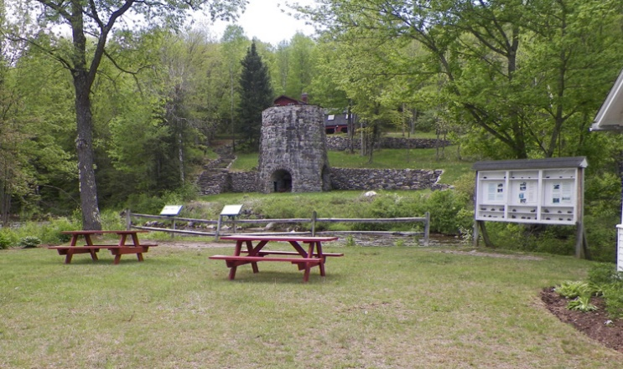
Coffin Pond Conservation Area, NH 18, Sugar HilI: “an outstanding example of a pull-off where there are many things to do.” | Site of the Stone Iron Furnace Historical Marker, NH 18, Franconia: “one of the most historically interesting places in the state and a magnet for visitors.
 | 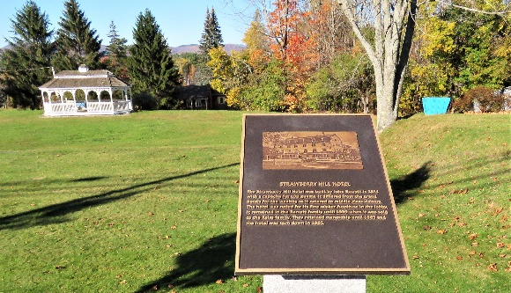
The Mountain Road, Weeks State Park, Lancaster: community efforts enhanced the visitor’s experience at this popular destination. | One of 17 historical markers placed by the Bethlehem Heritage Society at historic sites along Main Street.

Person submitting this application: Date Submitted:
Name: Address:
Contact Phone: Contact Email:

Person to contact for further information about the project (optional):
Name: Address:
Contact Phone: Contact Email:

Who is responsible for the project (municipality, agency, organization, or landowner) if different than applicant?

Awardee will receive a $1,000 cash prize for charitable, non-profit or volunteer organization(s) involved with the project. If this project wins an award, which charitable, non-profit or volunteer organization(s) will receive (share) the cash prize?

Nomination Category (please select one)
□ By the Byway Award - outstanding byway enhancement resulting from community efforts that encourage people to pull off the byway to photograph the scenery, take a walk, have a snack, meet friends or otherwise enjoy a few minutes or more at a local rest area, pull-off, or trailhead.
□ Read the Marker Award - outstanding byway enhancement resulting from community efforts that encourage people to pull off the byway to learn about the people or events described on a historical marker.

Project Location

What Town is the project located in?

What highway US/NH Route or road is the project located on?

Please describe below the project location and attach a map of the project location (google map with pin location is acceptable).

Project Description
Please describe below a) the motivation for the project: b) the work completed and when it was done, c) the people, organizations, or municipalities who were involved, and d) the way that it was funded.

If additional space is needed, please attach.
Site Use Description
Please provide a description of how this site is used by residents and byway travelers (attach photos and other indications of community support for and use of the site).

If additional space is needed, please attach.

Photographs
Attach photographs of the site before (if available) and after completion of the project to demonstrate the extent of the enhancements.

Submit the application to Nick Altonaga, Transportation Planner at naltonaga@nccouncil.org
by September 30, 2022

In order to recognize and reward local efforts to enhance the North Country’s Scenic & Cultural Byways, the North Country Scenic Byway Council seeks nominations for two types or categories of Byway Enhancement Award projects.
- By the Byway Award - outstanding byway enhancement resulting from community efforts that encourage people to pull off the byway to photograph the scenery, take a walk, have a snack, meet friends, or otherwise enjoy a few minutes or more at a local rest area, pull-off, or trailhead.
- Read the Marker Award - outstanding byway enhancement resulting from community efforts that encourage people to pull off the byway to learn about the people or events described on a historical marker.
To qualify for an award, the nominated site must offer multiple reasons for stopping and provide safe access from the highway to a formal (paved or unpaved) parking area for the site. Sites that have safe access and parking will then be evaluated on by the Awards Committee based upon the following criteria:
- Quality of the site: how attractive is the site when viewed from the byway and what amenities are available at the site?
- Nature of enhancements: what was done to improve the safety or quality of the site?
- Community involvement: how extensive was community involvement in initiating and completing the project?
- Demonstrated use of the site: what evidence is provided to show that the site enhancements have attracted or are likely to attract more people to the site?

The table below provides weights for each of these criteria.

Evaluation Criteria for the By the Byway Award
Criteria | Description | Weighting
Quality of Site
- Attractiveness of Site | How attractive is the site? | 10%
- Site Amenities | Are there multiple reasons to stop at this site? | 30%
Nature & Extent of Improvements | To what extent did the project improve the safety or quality of the site? | 40%
Community Involvement | How extensive was community involvement? | 10%
Demonstrated Use of Site | Did the project result in increased use of the site? | 10%

Evaluation Criteria for the Read the Marker Award
Criteria | Description | Weighting
Quality of Site
- Attractiveness of Site | How attractive is the site?  Can people easily walk right up to the marker? | 10%
- Historical Evidence | What evidence is available at the sight for the events, people or history described on the marker? | 20%
- Site Amenities | Are there multiple reasons to stop at this site? | 10%
Nature & Extent of Improvements | To what extent did the project improve the safety or quality of the site? | 40%
Community Involvement | How extensive was community involvement? | 10%
Demonstrated Use of Site | Did the project result in more people reading the historical marker? | 10%

